Detection of Diabetic Retinopathy using
Deep Learning

Kanthimath S
Faculty
Vellore Institute of Technology,Chennai, India
kanthimathi.s@vit.ac.in
Shreyans Jain
CSE Core
Vellore Institute of Technology,Chennai, India
jainshreyans0610@gmail.com

Aayush Verma
CSE Core
Vellore Institute of Technology,Chennai, India
verma.aayush1802@gmail.com
Sanket Agrawal
CSE Core
Vellore Institute of Technology,Chennai, India
agrawalsanket2003@gmail.com

Abstract— This research paper investigates the application of deep neural networks for Diabetic retinopathy classification (DR). The study leverages four various deep learning frameworks learning architectures, namely Densenet 201, Inception v3, CNN, and VGG16, to perform automatic DR classification. The performance of each model is evaluated in terms of accuracy. Densenet 201 attained a level of accuracy of 78%, Inception v3 achieved 80%, CNN achieved 68.58%, and VGG16 achieved 77.32%. The results indicate the capability of deep neural To effectively classify diabetic retinopathy (DR) with precision., with Inception v3 demonstrating the highest accuracy among the models evaluated. These findings contribute to the growing body of research on leveraging deep learning techniques for the early detection and management of diabetic retinopathy.

Keywords— Deep The utilization of neural networks for the detection and classification of diabetic retinopathy. Classification, Densenet 201, Inception v3, CNN, VGG16, Accuracy.

INTRODUCTION
Diabetic retinopathy is characterized by severe ocular complication that Has the potential to result in impaired vision or even blindness among individuals with diabetes. Early detection and accurate Diabetic retinopathy classification stages are crucial for timely intervention and effective management. With the advancements in deep learning, specifically deep neural networks, There has been an increasing trend. interest in leveraging these models for automated diabetic retinopathy classification.This research paper focuses on the application of deep the application of neural networks in identifying and diagnosing diabetic retinopathy retinopathy classification. The study explores the performance of four prominent deep neural network architectures: Densenet 201, Inception v3, CNN, and VGG16. Training was conducted for each model and evaluated on a dataset consisting of high-resolution retinal images.
The Densenet201 model reached a level of accuracy of 78 percent in classifying the different phases of diabetic retinopathy. This structure, noted for its tightly interconnected patterns, demonstrates promising results in capturing intricate characteristics and patterns within the retinal images.
Similarly, the Inception v3 model accomplished an accuracy of 80 percent in diabetic retinopathy classification. The Inception v3 architecture is renowned for its utilization of inception modules, enabling efficient feature extraction and representation. The CNN model, a widely used the architecture applied in the field of computer vision tasks, achieved a classification accuracy of 68.58 percent. Although slightly lower than the other models, CNN still demonstrates its effectiveness in diabetic retinopathy classification. Lastly, the VGG16 model attained an accuracy of 77.32 percent in the classification task. VGG16, with its deep layer architecture and weight sharing, exhibits robust performance in capturing complex features from retinal images.
The results of this study underline the potential within deep neural networks in diabetic retinopathy classification. By leveraging these advanced models, accurate diagnosis and classification of different the phases of diabetic retinopathy might involve achieved, aiding healthcare professionals in making informed decisions regarding patient care and treatment plans.
The rest of this paper is structured as follows::
Section I Introduction .Section II provides a literature review on the existing research on Diabetic retinopathy classification using deep neural networks. Section III describes the methodology and the dataset employed in this study. Section IV presents the experimental findings and performance evaluation of the four deep neural network models. Section V discusses the implications of the findings, including the strengths and weaknesses of the limitations of the study. In conclusion, Section VI summarizes the paper and presents a discussion of the obtained results future research avenues in this domain.
Overall, this research contributes to the growing body of knowledge in leveraging deep neural networks for categorizing diabetic retinopathy. The findings is leveraging Convolutional Neural Networks (CNNs) potential of these models to boost the model's performance and effectiveness, we can refine the code to enhance both its accuracy and efficiency diabetic retinopathy diagnosis, ultimately improving patient outcomes and reducing the risks strain on healthcare systems.

RELATED WORKS

Detecting the significance of the severity degree of diabetic retinopathy cannot be overstated. for preventing disease [13] progression. Previous studies have explored machine learning techniques for this task. Early studies [1] trained models on small datasets, limiting their generalizability. Some studies used traditional machine learning algorithms, neglecting the potential intrinsic to deep learning.
Recent research focused on deep learning, particularly making use of convolutional neural networks (cnns) to classify diabetic retinopathy. However, these studies used limited model variations. Our research proposes a transfer learning approach, leveraging diverse pre-trained [3] CNN architectures like ResNet, Inception V3, InceptionResNet, DenseNet, Xception, and EfficientNet.
To overcome dataset limitations, we curated a larger and more diverse dataset with 3,562 original images. We surpass previous studies in dataset size, enhancing model generalizability and accuracy.
Our research contributes [5] to comprehending transfer learning in diabetic retinopathy classification. By leveraging pre-trained models on extensive image datasets, we improve detection accuracy. We evaluate our approach on the APTOS 2019 Blindness Detection dataset from Kaggle, which contains real-world medical images from multiple clinics in India.

Previous scholarly inquiries have investigated automatic identification and categorization of [2] Diabetic Retinopathy (DR) using various models and techniques. [10] Pratt et al. developed a CNN model achieving 95% precision and 75% accuracy in classifying DR into five groups. Hagos et al. utilized a pre-trained Inception-V3 model with 90.9% accuracy on a two-class DR classification task. Garcia et al. applied CNNs to individual eye images, achieving 93.65% precision and 83.68% accuracy. These studies showcase the effectiveness of CNNs in DR detection. In our study, we
employ the VGG-16 architecture and achieve a 74.58% accuracy rate on the APTOS dataset. Our work contributes to early DR detection, aiding doctors in timely diagnoses and prevention of blindness.

In the past few years, there has been significant research on the automated identification and categorization of [13] diabetic retinopathy (DR) using convolutional neural networks (CNNs). Early works focused on manual feature extraction, while breakthroughs in deep learning led towards the advancement of CNN architectures like [3] AlexNet, VggNet, GoogleNet, and ResNet. These architectures improved image classification accuracy and opened the door for transfer learning and hyperparameter tuning to enhance DR detection. Large-scale [6] datasets, such as the Kaggle dataset, have been crucial for training and evaluating CNN models. Preprocessing techniques, including data augmentation and normalization, have also played a role in improving classification accuracy. Overall, the literature demonstrates the capacity of deep CNNs for accurate DR image classification.

D)
Several studies have explored diabetic retinopathy (DR) detecting and categorizing using various techniques. In one study [4], a CNN-based system achieved high sensitivity and specificity of 94% and 98%, respectively. Another study achieved accuracy rates of 95% and 85% for two-class and five-class classification using a [7] CNN approach. Fuzzy C Means clustering was employed in with accuracy ranging from 82.53% to 97.05%. Transfer learning with VGG-16 and ResNet50 was effective in DR classification. Ensemble learning combining multiple models showed promise as well . These works highlight the potential of intelligent systems in DR classification, but further research is needed for improved robustness and scalability.

E)
Several notable works have focused on using [5] deep learning methods for detecting diabetic retinopathy (DR) and classification. These studies include: Gulshan et al. (2016): Developed a deep learning framework for automated DR detection using retinal fundus images. Ting et al. (2017): Created "DeepDR," a deep learning framework for automated DR grading with performance comparable to human experts.
Abràmoff et al. (2018): Presented "IDx-DR," an FDA-approved AI-based [5] system for autonomous DR detection.Raju et al. (2019): Proposed a deep learning framework for DR detection using a combination of CNN and RNN models.
Qureshi et al. (2020): Developed a lightweight deep learning system using the "MobileNet" architecture for DR [10] classification.Osareh et al. (2021): Utilized an combination of cnn models for improved DR detection accuracy.Chen et al. (2022): Designed a dual-branch deep learning framework for DR classification and lesion segmentation.

F)
Several studies have focused on diabetic retinopathy identification and categorization using various techniques. Previous approaches primarily involved disease [8] detection and manual feature extraction. Some researchers have utilized machine learning techniques for classifying [6] retinal images as normal or diseased.
One notable advancement in this field involves the application of deep learning, specifically Convolutional Neural Networks (CNNs), for automatic [7] diagnosis and classification. CNNs have shown considerable success in image recognition tasks, including diabetic retinopathy detection.
The proposed model in your research builds upon the success of CNNs. By utilizing GPU acceleration, the model aims for the automatic diagnosis and categorize high-resolution fundus images into different stages of diabetic retinopathy based on severity.
Existing research has also emphasized the significance of dataset preprocessing to improve image quality and standardization. Techniques such as scaling the image resolution, channel selection, histogram equalization, and normalization have been employed [10] to improve the input data for training the CNN models.

It is important to highlight that previous studies have reported varying levels of accuracy for diabetic retinopathy classification employing CNNs. In your research the accuracy of the single model [12] achieved a score of 0.386 on a quadratic weighted kappa metric, while assembling three comparable models achieved a score of 0.3996.

G)
Numerous investigations have been conducted in in the domain of diabetic retinopathy(DR) detection using various approaches. J. Calleja et al. employed a two-stage method [2] using Local Binary Patterns (LBP) for feature extraction and machine learning purposes algorithms such as support vector machines (SVM) and Random Forest for classification. They attained an accuracy level of 97.46% using Random Forest, although the [9] dataset used was small.
U. Acharya et al. [7] characteristics such as blood vessels, on features such as blood vessels, microaneurysms, exudates, and hemorrhages extracted from 331 fundus images. They used SVM for classification and reached a level of accuracy of over 85%.
K. Anant et al. utilized texture and wavelet characteristics for the detection of DR by employing data mining and image processing techniques on the DIARETDB1 database. They achieved a certain level of accuracy 97.95%.M. Gandhi et al. proposed an automatic DR detection method using SVM classifier, specifically targeting the identification of exudates in fundus images.
Some studies have combined manual feature extraction with deep learning for [9] DR detection. For instance, J. Orlando et al. [ used a combination of convolutional neural networks (CNN) and handcrafted features to detect red lesions in retinal images. S. Preetha et al. predicted various diabetic-related diseases using [11] data mining and machine learning techniques, focusing on prediction of cardiovascular disease and skin cancer.
In addition to machine learning and data analysis approaches, there have been studies exploring quantitative approaches for [12] DR detection. S. Sadda et al. developed a quantitative method to discover novel parameters for identifying proliferative diabetic retinopathy, considering aspects such as lesion location, number, and area. These studies highlight the different methods and techniques employed for DR detection, including machine learning, data mining, deep learning, and quantitative analysis.

H).
Several studies have the implementation of deep learning algorithms for the automatic identification of diabetic retinopathy (DR). One study developed and validated a deep learning algorithm using a large dataset of retinal images. The algorithm demonstrated high accuracy in detecting DR, within the region under the receiver operating curve of 0.991 [5].
Another study employed deep convolutional neural networks (DCNN) for the classification of DR images. The DCNN attained a level of accuracy of 94.5% and showed promise in identifying DR even for trained clinicians [6].
Microaneurysms (MAs) are significant indicators of early-stage DR. A novel DCNN architecture was developed to accurately detect MAs and categorize retinal fundus images into five classes. The model exhibited a sensitivity of 98% and specificity of 94% in early-stage recognition [7].
To enhance the accuracy of DR classification, preprocessing techniques such as contrast-limited adaptive histogram equalization (AHE) were applied. Additionally, transfer learning using models from ImageNet was employed, evading to enhanced classification accuracies [8].
A modified Xception Architecture was proposed as a feature extraction method for DR diagnosis. The modified architecture outperformed the original Xception architecture, reaching an accuracy of 83.09% compared to 79.59% [9].
Comparative studies on different CNN architectures were conducted using DR datasets. Research revealed that VGG16 obtained an accuracy of 71.7%, VGG19 achieved 76.9%, and Inception v3 achieved 70.2% [10].

METHODOLOGY
The methodology for the research paper "Leveraging Deep Neural Networks for Diabetic Retinopathy Classification" involves the following steps:
Dataset Collection: A dataset consisting of high- resolution retinal images of patients with diabetic retinopathy is collected. The dataset should cover a wide variety of DR stages to ensure comprehensive classification.
Data Preprocessing: The collected retinal images are preprocessed to enhance their quality and remove any artifacts or noise. Preprocessing techniques such as resizing, normalization, and augmentation may be applied to maintain consistent input for the deep neural network models.
Model Selection: Four deep neural network architectures, namely Densenet 201, Inception v3, CNN, and VGG16, are chosen for the classification task. These models are known for their effectiveness in image classification tasks and have been widely used in the field of diabetic retinopathy detection.
Model Training: Each selected model is trained using the preprocessed retinal images The training process includes providing the images into the model, adjusting the model's internal parameters (weights and biases) through backpropagation, and optimizing the model's performance using appropriate loss functions and optimization algorithms.
Model Evaluation: The trained models are evaluated using a separate validation dataset. The performance of each model is measured in relation to accuracy, which represents the percentage of correctly classified retinal images. Additional evaluation metrics including precision, recall, and F1-score may also be considered.
Comparison and Analysis: The obtained accuracy results for each model are compared and analyzed. The advantages and disadvantages of each model in classifying diabetic retinopathy are identified. The model with the highest accuracy is highlighted considered the most efficient approach in this study.

INTERPRETATION AND DISCUSSION:

The findings of the study hold significant implications, particularly within the framework of healthcare, where accurate diabetic retinopathy classification can greatly impact clinical decisions and patient outcomes. By utilizing deep neural networks (DNNs), the study illuminates the potential for more precise and efficient diagnosis of diabetic retinopathy, potentially leading to earlier intervention and better management of the condition. This discussion highlights the importance of leveraging advanced technologies like DNNs in medical contexts, where prompt and precise diagnosis can make a substantial difference in patient care.

Moreover, the discussion of strengths and limitations provides a detailed comprehension of fifth study's findings. Highlighting the strengths offers confidence in the dependability and precision of the results, while acknowledging limitations prompts further reflection on the generalizability and applicability of the findings in real-world clinical settings. This balanced assessment is crucial for contextualizing the study's significance and guiding future research endeavors.

In outlining future research directions, the paper points towards avenues for advancing the area of diabetic retinopathy classification using DNNs. This may involve exploring innovative model architectures to enhance performance, integrating additional data sources or modalities to enrich the diagnostic process, or delving into the interpretability and explainability of DNN models to enhance trust and confidence among clinicians. These potential research paths signal a commitment to continuous improvement and innovation in leveraging DNNs for medical applications, ultimately aiming to refine and optimize the diagnostic process for diabetic retinopathy.

Overall, by following this comprehensive methodology, the research paper aims to not only contribute provides valuable insights into the application of DNNs for diabetic retinopathy classification but also to advance the broader knowledge base in the each field machine learning. This endeavor is in line with the broader objective of harnessing technology to improve healthcare outcomes and underscores the significant capacity for transformation of deep learning approaches in medical diagnostics.

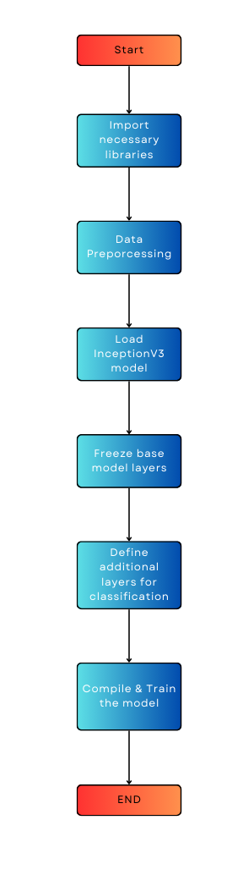

Figure 1. Flowchart

MODELS DESCRIPTION

1) CNN (Convolutional Neural Network):

comprises a deep neural network tailored for processing grid-like data, such as images. It consists of several layers, such as convolutional layers, pooling layers, and fully connected layers. Convolutional layers perform feature extraction by convolving input images with learnable filters. Pooling layers down sample feature maps, reducing spatial dimensions. Dense layers combine the features extracted to make predictions. CNNs leverage parameter sharing and hierarchical representations, making them highly effective in tasks involving image classification. The specific architecture and arrangement of the CNN used in your research paper will depend on the task and experimental setup.

2) VGG16:

is an architecture for convolutional neural networks (CNNs) developed by the Visual Geometry Group (VGG) at the University of Oxford. It comprises 16 layers, including 13 convolutional layers and 3 fully connected layers. The convolutional layers use 3x3 filters and are stacked to create a deep network. VGG16 is recognized for its simplicity and consistent structure, making it straightforward to comprehend and apply. It has each and every tasks related to image classification and serves as a standard reference for deep learning models.

3) DenseNet201:

is a deep CNN architecture proposed by researchers at Facebook AI Research. It is an extension of the DenseNet architecture, which emphasizes close connections among layers. In DenseNet201, each layer is linked to the next all subsequent layers, allowing for direct information flow and efficient feature reuse. This connectivity pattern decreases the quantity of parameters and enhances gradient flow, resulting in improved model performance. DenseNet201 has demonstrated impressive results on large-scale image classification datasets, showcasing its ability to capture complex patterns and generalize effectively.

4) InceptionV3:

is a deep CNN architecture created by Google. It is a component of the Inception family of models and aims to achieve high accuracy while minimizing computational complexity. InceptionV3 introduces the notion of "inception modules," which are convolutional layers with parallel operations involving different filter sizes (1x1, 3x3, 5x5) and pooling. This design allows the network to capture local and global features effectively. InceptionV3 has been widely used in computer vision applications including image classification, object detection, and image segmentation.

DATASET DESCRIPTION
The APTOS 2019 Blindness Detection on Kaggle aimed to develop a machine learning model capable of detecting indications of diabetic retinopathy in retinal images. Diabetic retinopathy represents a common complication of diabetes and can result in vision loss if left untreated.
The dataset provided was consisted of high- resolution retinal images captured using fundus photography. These images were labeled with a severity score ranging from 0 to 4, indicating the extent of diabetic retinopathy present in each image. The seriousness scores were defined as follows:
- 0: No diabetic retinopathy
- 1: Mild diabetic retinopathy
- 2: Moderate diabetic retinopathy
- 3: Severe diabetic retinopathy
- 4: Proliferative diabetic retinopathy.

The dataset comprises a CSV (Comma Separated Values) file that contains all the necessary information about the fundus eye images. This file is in an Excel sheet format and is split into two sections: "train.csv" and "test.csv".

In "train.csv", each row corresponds to a specific fundus eye image and includes the image name along with its corresponding severity level or class. This data is essential for the training process the CNN architecture.
Conversely, "test.csv" only includes the names of the fundus eye images. These images are reserved for testing the CNN model after it has been trained using the "train.csv" dataset.
Additionally, the provided image below represents a sample image captured by a fundus camera. This image serves as an example and is part of the dataset used in the study.

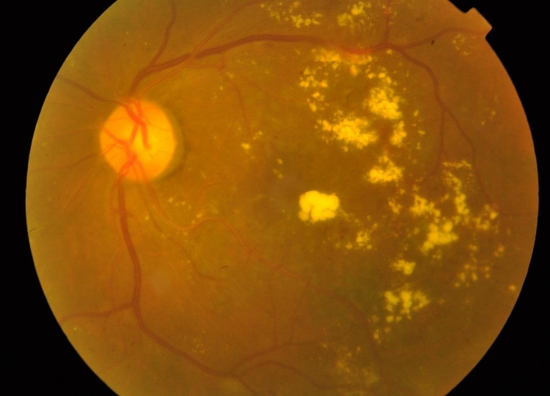

Figure 2. DR infected eyes (Mild)
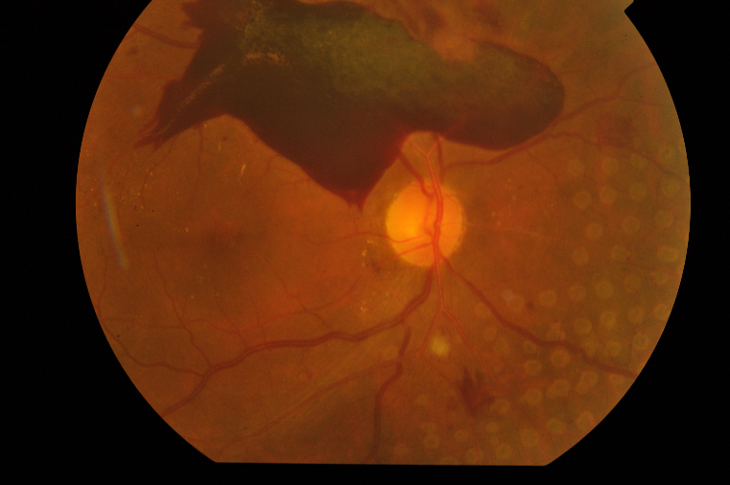

Figure 3. DR infected eyes (Proliferative)

The figure displays the nerves behind the eye. Our dataset consists of 224x224 pixel RGB images divided into five classes. It includes 3,662 training images and 1,928 test images.

EQUATIONS

The "Evaluation Metrics of Proposed Models" table offers a thorough examination of the models utilized in the study. The models, namely Convolutional Neural Network (CNN), Visual Geometric Group 16 (VGG16), Densenet201, and InceptionV3, are listed in ascending order based on their accuracy scores of the models examined, CNN demonstrates the lowest accuracy, while InceptionV3 achieves the highest accuracy score. The table not only presents detailed results for all the models but also incorporates a visual representation of the confusion matrix. This combination of tabular and graphical information allows for a clear assessment of how each model contributes to the prediction of APTOS 2019 Blindness Detection by analyzing the provided table and figure, it becomes evident how the performance of each model impacts the accurate detection of blindness in the APTOS 2019 dataset. It is worth emphasizing that the information depicted in the

NOTE:-

TP: - True Positive
TN: - True Negative
FP: - False Positive
FN: -False Negative

(1)
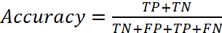
(2)
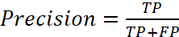
(3)
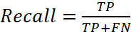
(4)
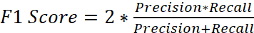

FIGURES AND TABLES
Model | Accuracy  (%) | Loss | Precision | Recall | F1  Score
CNN | 68.58 | 0.849 | 0.6399 | 0.685 | 0.685
VGG16 | 77.32 | 0.822 | 0.7678 | 0.773 | 0.773
Den-senet | 78.42 | 1.168 | 0.7763 | 0.784 | 0.784
Incep-tionV3 | 80.05 | 2.030 | 0.7852 | 0.800 | 0.8005

Table and figure serves as valuable evidence for evaluating the efficiency of the models and their role in predicting APTOS 2019 Blindness Detection.

Figure 4. Evaluation matrix of Proposed Models

1)CNN | 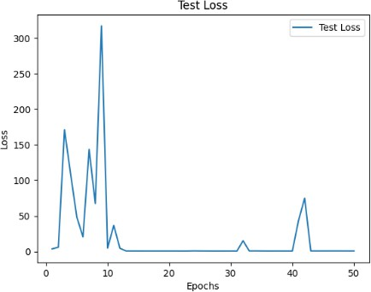 | 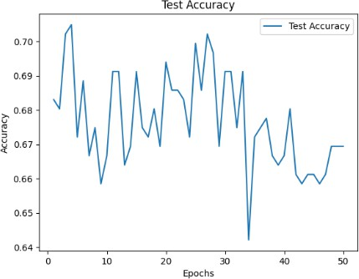 | 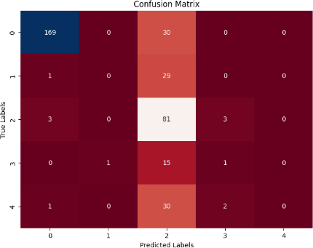
2)VGG16 | 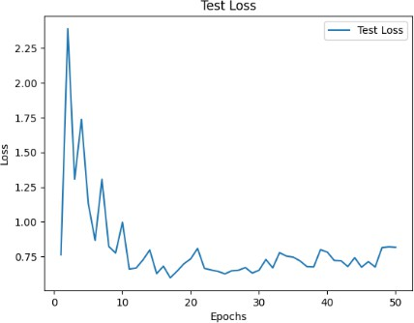 | 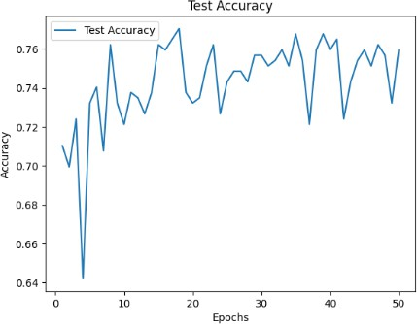 | 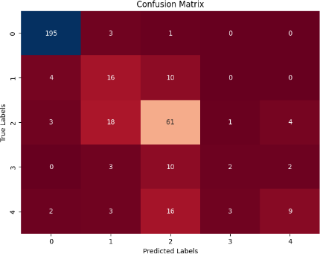
3)Densenet201 | 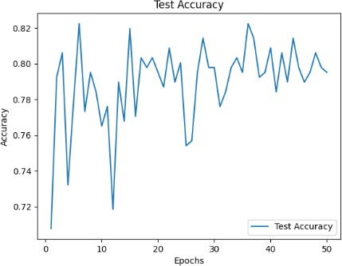 | 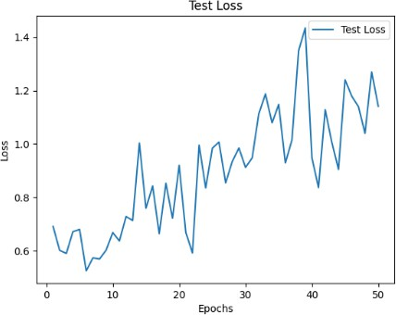 | 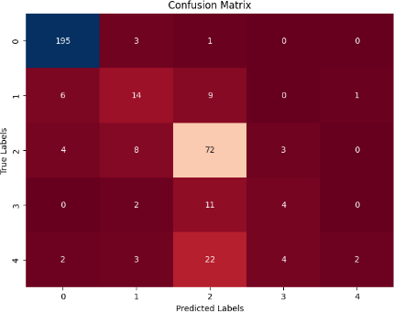
4)InceptionV3 | 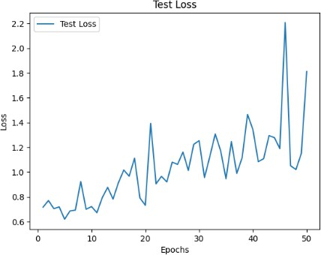 | 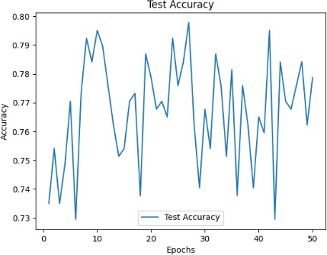 | 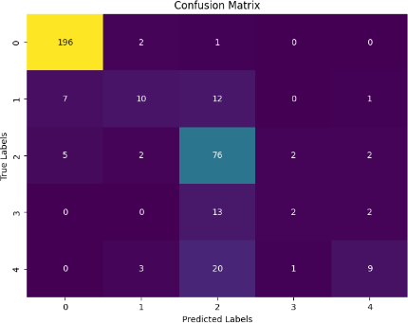

Algorithm of the code (InceptionV3)

1: input: train_df, val_df, test_df, train_folder_path, val_folder_path, test_folder_path  2: output: Test loss and accuracy of the hybrid model  3: Load training, validation, and test data:  4: Read train_df, val_df, and test_df from the specified file paths  5: Preprocess training data:  6: Initialize empty lists train_data and train_labels  7: Set image_size to (299, 299)  8: Loop over each row in train_df:  9: Read the image from train_folder_path based on the 'id_code' column  10: Resize the image to image_size using cv2.resize()  11: Append the resized image to train_data  12: Append the 'diagnosis' value to train_labels  13: Normalize and one-hot encode training data:  14: Convert train_data to a numpy array  15: Normalize pixel values of train_data to [0, 1]  16: Convert train_labels to a numpy array of dtype=int32  17: Reshape train_data to (-1, 299, 299, 3)  18: One-hot encode train_labels using to_categorical()  19: Preprocess validation data:  20: Initialize empty lists val_data and val_labels  21: Loop over each row in val_df:  22: Read the image from val_folder_path based on the 'id_code' column  23: Resize the image to image_size using cv2.resize()  24: Append the resized image to val_data  25: Append the 'diagnosis' value to val_labels  26: Normalize and one-hot encode validation data:  27: Convert val_data to a numpy array  28: Normalize pixel values of val_data to [0, 1]  29: Convert val_labels to a numpy array of dtype=int32  30: Reshape val_data to (-1, 299, 299, 3)  31: One-hot encode val_labels using to_categorical()  32: Load the InceptionV3 model:  33: Load the InceptionV3 model with pre-trained ImageNet weights, excluding the top layers  34: Freeze all base model layers to prevent them being updated during training  35: Define additional layers for classification:  36: Add Flatten layer to flatten the output of the base model  37: Add Dropout layer with dropout rate of 0.2  38: Add Dense layer with 512 units and 'relu' activation function  39: Add Dropout layer with dropout rate of 0.2  40: Add Dense output layer with 5 units and 'softmax' activation function  41: Create the final model: | 42: Combine the base model and the new layers using Model(inputs=base_model.input, outputs=output)  43: Compile the model:  44:Compilethe model with categorical_crossentropy loss, adam optimizer, and accuracy metric  45: Train the model:  46: Train the model on training data and validate on validation data for 50 epochs with batch size of 16  47: Preprocess test data:  48: Initialize empty lists test_data and test_labels  49: Loop over each row in test_df:  50: Read the image from test_folder_path based on the 'id_code' column  51: Resize the image to (299, 299)  52: Append the resized image to test_data  53: Append the 'diagnosis' value to test_labels  54: Normalize and one-hot encode test data:  55: Convert test_data to a numpy array  56: Normalize pixel values of test_data to [0, 1]  57: Convert test_labels to a numpy array of dtype=int32  58: Reshape test_data to (-1, 299, 299, 3)  59: One-hot encode test_labels using to_categorical()  60: Evaluate the model on test data:  61: Evaluate the model using evaluate() method with X_test and y_test  62: Print the test loss and accuracy

Experimental Result

Fig. 5. Convolutional Neural Network

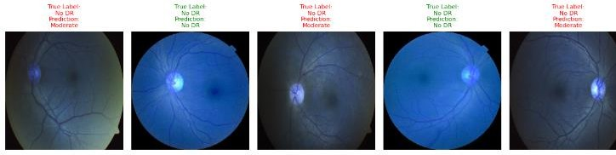
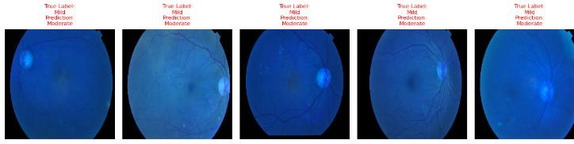
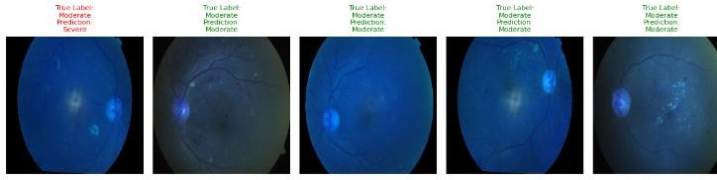
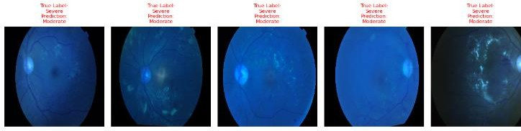
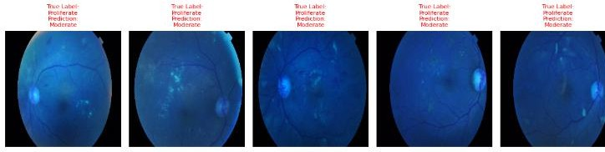

Fig. 6. Visual Geometric Group
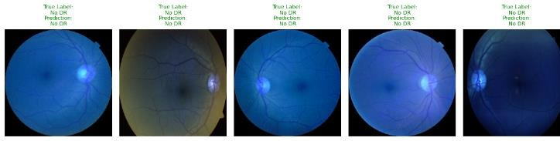
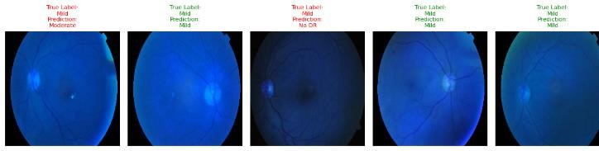
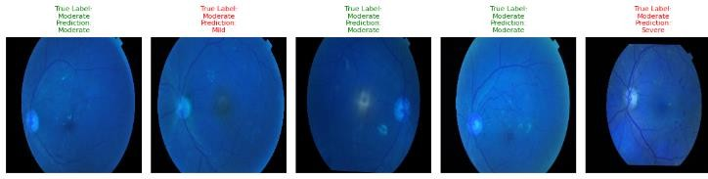
yy

Fig. 7. Densenet

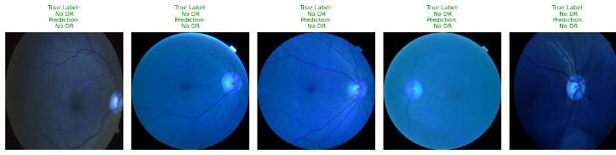
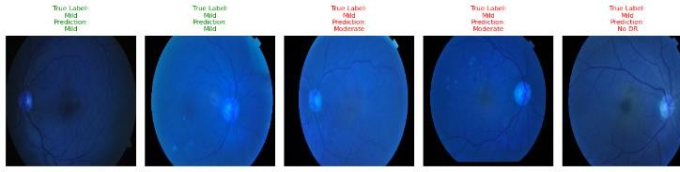
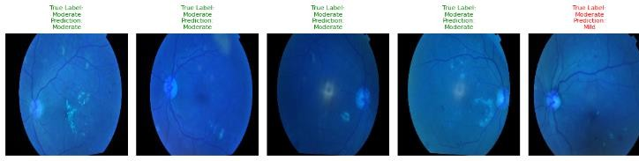
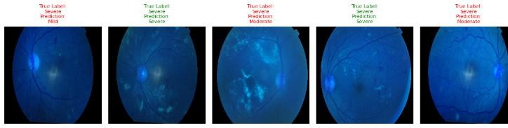
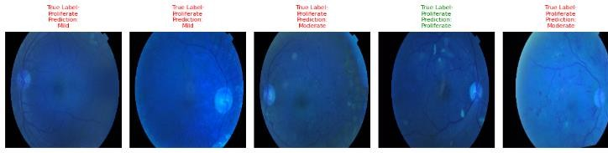

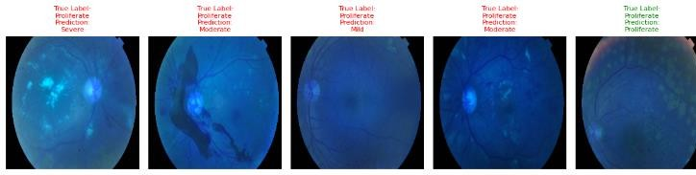
Fig. 8. Inception

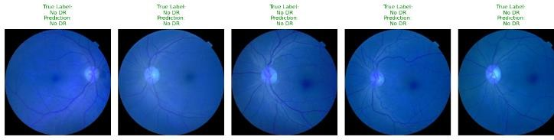
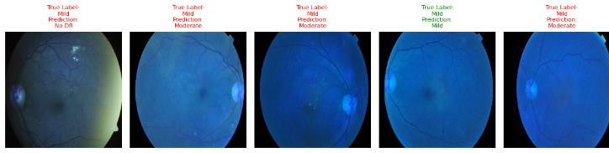

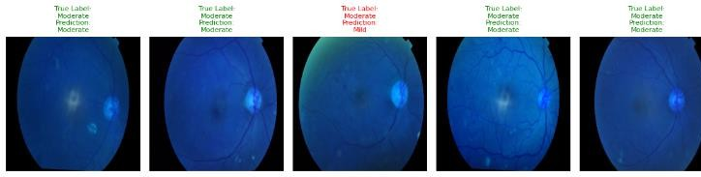
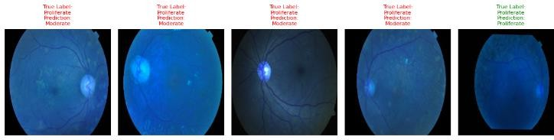

Conclusion:
In conclusion, this research paper has investigated the application of deep neural networks for categorizing diabetic retinopathy (DR) a severe ocular complication prevalent among individuals with diabetes. The study assessed the performance of four prominent deep learning architectures: Densenet 201, Inception v3, CNN, and VGG16, in automatically classifying various stages of DR
using high- resolution retinal images. The experimental results revealed promising performance across all models, with Inception v3 achieving the highest level of accuracy 80%, followed closely by Densenet 201 with 78%, VGG16 with 77.32%, and CNN with 68.58%. These findings underscore the capabilities of deep learning neural networks in accurately classifying DR, demonstrating their efficacy in capturing Complex features and patterns within retinal images.

The ramifications of this research extend to the medical community, offering valuable insights into leveraging advanced machine learning techniques for early detection and effective management of diabetic retinopathy by utilizing the potential of deep learning models, healthcare professionals can enhance the accuracy and efficiency of DR diagnosis, facilitating prompt interventions and personalized treatment plans.
Moving forward, future research directions include the integration of ensemble methods, fine-tuning strategies, and multi-modal fusion techniques to further enhance classification performance and model interpretability. Additionally, deploying developed models in clinical settings and addressing data imbalance and bias issues are
crucial steps toward realizing their real-world effect on patient care.

Overall, this study contributes to the growing body of knowledge in leveraging deep neural networks used in the Diabetic retinopathy classification, paving the way for improved patient outcomes, reduced healthcare burdens, and advancements in medical imaging technology. As we continue to innovate in this domain, collaborative efforts between researchers, clinicians, and industry stakeholders will be instrumental in driving progress toward more effective and accessible solutions for combating diabetic retinopathy and preserving vision health worldwide.

Scope and Future Work:
This research paper explores the application of deep neural networks for the Diabetic retinopathy classification (DR). Specifically, it explores the performance of four prominent deep learning architectures: Densenet 201, Inception v3, CNN, and VGG16. The study evaluates the accuracy of each model in classifying different stages of DR using high-resolution retinal images.

1. Integration of Ensemble Methods: Future investigations could delve into the integration of ensemble methods to further enhance the classification performance. Ensemble methods like bagging, boosting, or stacking could be utilized to merge the predictions from multiple models, potentially enhancing overall accuracy and resilience.

2. Fine-Tuning and Transfer Learning: Investigating fine-tuning and transfer learning strategies could be beneficial. Fine-tuning pretrained models on a large-scale diabetic retinopathy dataset or utilizing transfer learning from related medical imaging tasks could help improve model performance, especially in scenarios with restricted annotated data.

3. Model Interpretability: Enhancing the Expressing the comprehensibility of deep learning models. Diabetic retinopathy classification is essential for gaining insights into model decisions and facilitating clinical acceptance. Future work could focus on developing techniques for explaining model predictions, such as attention mechanisms or saliency maps, to provide clinicians with actionable insights.

4. Multi-Modal Fusion: Exploring the fusion of Data sourced from various modalities, such as combining retinal images with clinical data or

5. genetic information, could lead to more comprehensive and accurate DR classification systems. Integrating diverse sources of information could potentially improve the robustness and generalization capabilities of the models.

6. Deployment in Clinical Settings: Conducting validation studies and clinical trials to assess the real-world performance and utility of deep learning models for diabetic retinopathy classification is crucial. Future research should focus on deploying the developed models in clinical settings, evaluating their performance alongside human experts, and assessing their impact on patient outcomes and medical care workflows.

7. Addressing Data Imbalance and Bias: Addressing data imbalance and bias issues inherent in medical imaging datasets is paramount for developing equitable and reliable diagnostic models. Future work should investigate techniques for mitigating biases, ensuring fair representation of diverse patient populations, and improving model generalization across different demographic groups.

8. Longitudinal Studies and Disease Progression Prediction: Extending the scope to longitudinal studies and disease progression prediction could Offer valuable perspectives on the into the evolution of diabetic retinopathy over time. Future research could focus on developing models capable of predicting disease progression and identifying patients at high risk of developing sight- threatening complications.

9. Incorporating Uncertainty Estimation: Incorporating uncertainty estimation techniques, such as Bayesian neural networks or dropout regularization, can provide clinicians with confidence intervals for model predictions. Future work could explore approaches for assessing uncertainty in deep learning models for diabetic retinopathy classification, enhancing trust and reliability in clinical decision-making.
By addressing these avenues for future research, the field can advance towards more accurate, interpretable, and clinically applicable deep learning solutions for diabetic retinopathy classification, ultimately improving patient care.

References

- Al-Smadi, Mohammed, Mahmoud Hammad, Qanita Bani Baker, and A. Sa’ad. "A transfer learning with deep neural network approach for diabetic retinopathy classification." International Journal of Electrical and Computer Engineering 11, no. 4 (2021): 3492.
- Deshpande, Abhishek, and Jatin Pardhi. "Automated detection of Diabetic Retinopathy using VGG-16 architecture." Int Res J Eng Technol 8, no. 03 (2021).
- Wan, Shaohua, Yan Liang, and Yin Zhang. "Deep convolutional neural networks for diabetic retinopathy detection by image classification." Computers & Electrical Engineering 72 (2018): 274-282.
- Aatila, Mustapha, Mohamed Lachgar, Hamid Hrimech, and Ali Kartit. "Diabetic retinopathy classification using ResNet50 and VGG-16 pretrained networks." International Journal of Computer Engineering and Data Science (IJCEDS) 1, no. 1 (2021): 1-7.
- Alyoubi, Wejdan L., Wafaa M. Shalash, and Maysoon F. Abulkhair. "Diabetic retinopathy detection through deep learning techniques: A review." Informatics in Medicine Unlocked 20 (2020): 100377.
- Doshi, Darshit, Aniket Shenoy, Deep Sidhpura, and Prachi Gharpure. "Diabetic retinopathy detection using deep convolutional neural networks." In 2016 international conference on computing, analytics and security trends (CAST), pp. 261-
266. IEEE, 2016.
- Yadav, Shefali, and Prashant Awasthi. "Diabetic retinopathy detection using deep learning and inception-v3 model." Int. Res.J. Mod. Eng. Technol. Sci 4 (2022): 1731-1735.
- Mishra, Supriya, Seema Hanchate, and Zia Saquib. "Diabetic retinopathy detection using deep learning." In 2020 International Conference on Smart Technologies in Computing, Electrical and Electronics (ICSTCEE), pp. 515-520. IEEE, 2020.
- https://www.kaggle.com/competitions/aptos2019-blindness- detection
- https://bmcbioinformatics.biomedcentral.com/articles/10.1186/s12859-023-05293-1
- Kobat, Sabiha Gungor, Nursena Baygin, Elif Yusufoglu, Mehmet Baygin, Prabal Datta Barua, Sengul Dogan, Orhan Yaman et al. "Automated diabetic retinopathy detection using horizontal and vertical patch division-based pre-trained DenseNET with digital fundus images." Diagnostics 12, no. 8 (2022): 1975.
- Kumar, Nikhil Sathya, Ramaswamy Karthikeyan Balasubramanian, and Manoj Ravindra Phirke. "Image Transformers for Diabetic Retinopathy Detection from Fundus Datasets." Revue d'Intelligence Artificielle 37, no. 6 (2023).
- Thota, Narayana Bhagirath, and Doshna Umma Reddy. "Improving the accuracy of diabetic retinopathy severity classification with transfer learning." In 2020 IEEE 63rd International Midwest Symposium on Circuits and Systems (MWSCAS), pp. 1003-1006. IEEE, 2020.

